EI Business Process Analysis

# Overview

EI communicates with Solution Manager via web services.



# Architecture

## Class Diagrams:

EI Service Locator helps the service dispatcher relocate to the right service handler action.

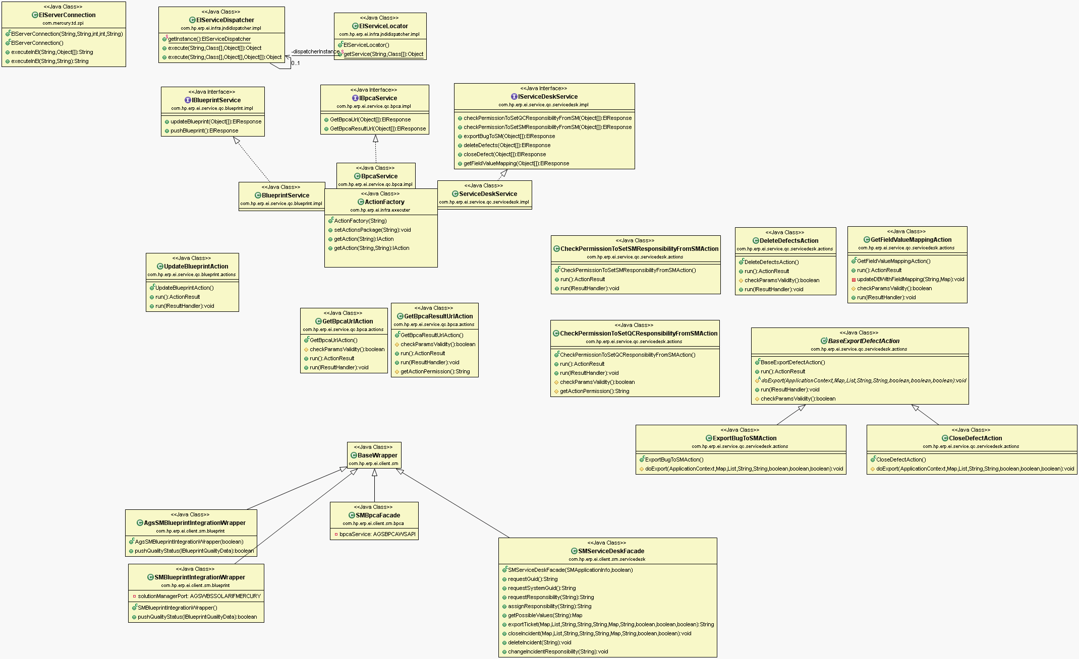

Remote Dispatchers for both QC and EI connections.

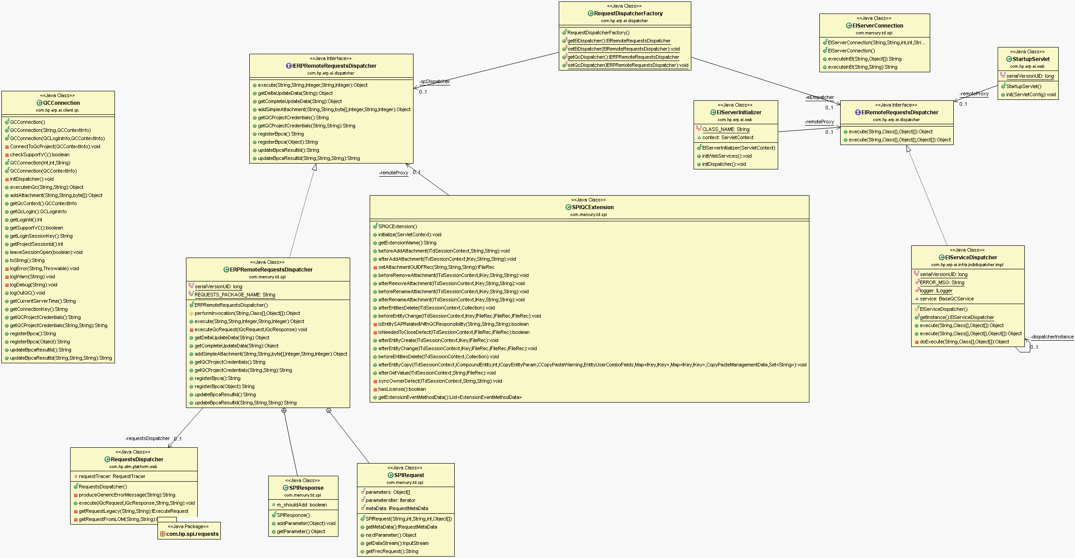

## General execution QC methods (e.g., CreateTestPlan):



## General execution EI methods (e.g., PushBlueprint):



# Business Process Scenarios

## Blueprint Synchronization

### Associate projects (SolMan -> ALM)

In this scenario, a SolMan project is associated to an ALM project so that they can have further interactions.

Firstly, SolMan calls associateProjects method via SMBlueprintHandlerSEI web service (AGSSMTESTDATAAPI in SecureAPI), which brings in project information and web service URLs of the SolMan server. Secondly, ALM creates a couple of web service client objects of Service Desk and binds the endpoints to the SolMan URLs. In this way, ALM is able to request for the GUID from SolMan by calling requestSystemGuid method via ICTSERVICEDESKAPIService. After receiving the GUID, ALM updates the database tables with it, along with the project association information and SolMan project information. The data tables involved are BLUEPRINTS in project DB and BLUEPRINT_PROJECTS in SA DB.



[1] Execution of associateProjects updates information into database. (It should be integration user instead of ALM user name and password in SecureAPI.)



[2] Constructor of SMServiceDeskFacade does endpoint bindings.



*Register endpoint for ICTSERVICEDESKAPIService:



### Map keywords (SolMan -> ALM)

This scenario comes automatically after associating projects succeeds. SolMan calls mapKeywords via SMBlueprintHandlerSEI web service.

### Get ALM project list (SolMan -> ALM)

SolMan calls getQualityCenterProjects via SMBlueprintHandlerSEI web service when navigating the project list in project associating dialog.

### Get Available UDF (SolMan -> ALM)

SolMan calls getAvailableUDFs via SMBlueprintHandlerSEI web service when mapping keywords.

### Push Clients (SolMan -> ALM)

SolMan calls pushClients via SMBlueprintHandlerSEI web service when associating projects.

### Send SolMan data to ALM (SolMan -> ALM)

SolMan calls pushBlueprint via SMBlueprintHandlerSEI web service.

### Import blueprints to ALM (ALM -> SolMan)

Same process as “Send SolMan data to ALM”.

### Send test results back to SolMan (ALM -> SolMan)

ALM calls AGS_WBS_SET_REQUIREMENT_RESULT via AGSWBSSOLARIFMERCURYService (AgsSmSetTestresults via AGSSMTESTRESULTAPI_Service in SecureAPI) by “Update Solution Manager”.

## Incident Synchronization

### Create and check Service Desk in ‘ictconf’ (SolMan -> ALM)

SolMan calls requestSystemGuid via ICTSERVICEDESKAPI web service to get the GUID of ALM.

### Sync a SolMan incident to ALM (SolMan -> ALM)

SolMan calls AddInfo via ICTSERVICEDESKAPI web service.

### Submit a solution to an incident from SolMan (SolMan -> ALM)

SolMan calls VerifyIncidentSolution via ICTSERVICEDESKAPI web service.

### Request responsibilities from SolMan (SolMan -> ALM)

There’s a SolMan ticket on this. Highly possible a SolMan bug.

### Get Field Mapping & Get Field Value Mapping (ALM -> SolMan)

ALM calls GetPossibleValues via ICTSERVICEDESKAPIService and IctIfMqcGetPossibleValues via ICTSERVICEDESKAPIMQC_Service web service.

### Transfer ALM defects to SolMan (ALM -> SolMan)

ALM calls AddInfo or ReplicateIncident via ICTSERVICEDESKAPIService web service.

### Assign/Request responsibility from ALM (ALM -> SolMan)

ALM calls IctIfMqcAssignResponsibili/ IctIfMqcRequesResponsibili via ICTSERVICEDESKAPIMQC_Service web service.

### Delete defects from ALM (ALM -> SolMan)

ALM calls IctIfMqcDeleteIncident via ICTSERVICEDESKAPIMQC_Service web service.

### Close defects from ALM (ALM -> SolMan)

ALM calls CEDESKAPIServi via ICTSERVICEDESKAPIService web service.

## BPCA Integration

### Ping BPCA (SolMan -> ALM)

SolMan calls AgsBpca3ptmPing via AGSBPCA3PTMAPI web service.

### Register BPCA (SolMan -> ALM)

SolMan calls AgsBpca3ptmRegisterBpca via AGSBPCA3PTMAPI web service.

### Create test plans (SolMan -> ALM)

SolMan calls AgsBpca3ptmCreateTestplan via AGSBPCA3PTMAPI web service.

### Extend test plans (SolMan -> ALM)

SolMan calls AgsBpca3ptmExtendTestplan via AGSBPCA3PTMAPI web service.

### Get test plans (SolMan -> ALM)

SolMan calls AgsBpca3ptmGetTestplans via AGSBPCA3PTMAPI web service.

### Get test cases (SolMan -> ALM)

SolMan calls AgsBpca3ptmGetTestcases via AGSBPCA3PTMAPI web service.

### Get BPCA URL (ALM -> SolMan)

SolMan calls AgsBpcaWsGetBpcaUrl via AGSBPCAWSAPI_Service web service.

### Get BPCA result (ALM -> SolMan)

SolMan calls AgsBpcaWsGetResultUrl via AGSBPCAWSAPI_Service web service.

# Web Service Method References

## SolMan -> ALM Method callings

### SMBlueprintHandlerSEI

#### In /SMBlueprintHandler and SMBlueprintHandler.wsdl

pushAppComponentsCrossProject

pushClients

mapKeywords

pushBlueprint

getUpdate

getQualityCenterProjects

getAvailableUDFs

getEntityURL

associateProjects

pushAppComponents

### AGSSMTESTDATAAPI

#### SecureAPI, in /services/AGSSMTESTDATAAPI with AGS_SM_TESTDATA_API.WSDL

#### Replacement for SMBlueprintHandlerSEI in SecureAPI

AgsSmPushAppComponents

AgsSmAssociateProjects

AgsSmGetUpdate

AgsSmDeassociateProjects

AgsSmGetEntityUrl

AgsSmGetExtToolProjects

AgsSmMapKeywords

AgsSmGetavailableCustfields

AgsSmPushAppCompCrossPrj

AgsSmPushBlueprint

AgsSmPushClients

### ICTSERVICEDESKAPI

#### In /services/ICT_SERVICE_DESK_API with ICT_SERVICE_DESK_API.wsdl

VerifyIncidentSolution

CloseIncident

RejectIncidentSolution (Not supported)

AddInfo

GetPossibleValues (Not supported)

RequestGuid

RequestSystemGuid

ProcessIncident

ReadCompleteIncident (Not supported)

ReplicateIncident

ListUnclosedIncidents (Not supported)

AcceptIncidentProcessing

### ICTSERVICEDESKAPIMQC

#### In /services/ICT_SERVICE_DESK_API_MQC with ICT_SERVICE_DESK_API_MQC.wsdl

IctIfMqcGetPossibleValues (Not supported)

IctIfMqcRequesResponsibili

IctIfMqcDeleteIncident (Not supported)

IctIfMqcAssignResponsibili

### AGSBPCA3PTMAPI

#### In /services/AGS_BPCA_3PTM_API with AGS_BPCA_3PTM_API.wsdl

AgsBpca3ptmGetTcTypes

AgsBpca3ptmCallGenService

AgsBpca3ptmCreateTestplan

AgsBpca3ptmRegisterBpca

AgsBpca3ptmNavigate

AgsBpca3ptmPing

AgsBpca3ptmGetContext

AgsBpca3ptmGetTcAttr

AgsBpca3ptmExtendTestplan

AgsBpca3ptmGetTestcases

AgsBpca3ptmGetTestplans

## ALM -> SolMan Method callings

### AGSBPCAWSAPI_Service

#### With AGS_BPCA_WS_API.wsdl

AgsBpcaWsPing

AgsBpcaWsGetGuid

AgsBpcaWsGetResults

AgsBpcaWsGetBpcaUrl

AgsBpcaWsGetParamDef

AgsBpcaWsGetResultUrl

AgsBpcaWsCallGenService

AgsBpcaWsSendTestplanId

### AGSSDADAPTERAPI_Service

#### SecureAPI, with AGS_SD_ADAPTER_API.wsdl

#### Replacement for ICTSERVICEDESKAPIMQC_Service in SecureAPI

AgsIfDeleteIncident

AgsIfGetIctDetails

AgsIfGetUrlForIct

AgsIfGetPossibleValues

AgsIfAssignResponsibility

AgsIfRequestResponsibility

### AGSSMTESTRESULTAPI_Service

#### SecureAPI, with AGS_SM_TESTRESULT_API.WSDL

#### Replacement for AGSWBSSOLARIFMERCURYService in SecureAPI

AgsSmSetTestresults

### AGSWBSSOLARIFMERCURYService

#### With AGS_WBS_SOLAR_IF_MERCURY.wsdl

AGS_WBS_SET_REQUIREMENT_RESULT

### ICTSERVICEDESKAPIService

#### With ICT_SERVICE_DESK_API.wsdl

AcceptIncidentProcessing

AddInfo

CloseIncident

GetPossibleValues

ListUnclosedIncidents

ProcessIncident

ReadCompleteIncident

RejectIncidentSolution

ReplicateIncident

RequestGuid

RequestSystemGuid

VerifyIncidentSolution

### ICTSERVICEDESKAPIMQC_Service

#### With ICT_SERVICE_DESK_API_MQC.wsdl

IctIfMqcAssignResponsibili

IctIfMqcDeleteIncident

IctIfMqcGetPossibleValues

IctIfMqcRequesResponsibili